**Virtualization** is a technique, which allows to share single physical instance of an application or resource among multiple organizations or tenants (customers). It does so by **assigning a logical name** to a physical resource and providing a **pointer to that physical resource** on demand.

Virtualization Concept

Creating a virtual machine over existing operating system and hardware is referred as Hardware Virtualization. Virtual Machines provide an environment that is logically separated from the underlying hardware.

The machine on which the virtual machine is created is known as **host machine** and **virtual machine** is referred as a **guest machine.** This virtual machine is managed by a software or firmware, which is known as **hypervisor.**

Hypervisor

The **hypervisor** is a firmware or low-level program that acts as a Virtual Machine Manager. There are two types of hypervisor:

**Type 1 hypervisor** executes on bare system. LynxSecure, RTS Hypervisor, Oracle VM, Sun xVM Server, VirtualLogic VLX are examples of Type 1 hypervisor. The following diagram shows the Type 1 hypervisor.

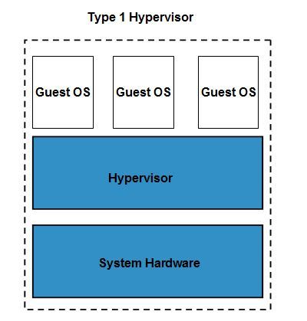

The **type1 hypervisor** does not have any host operating system because they are installed on a bare system.

**Type 2 hypervisor** is a software interface that emulates the devices with which a system normally interacts. Containers, KVM, Microsoft Hyper V, VMWare Fusion, Virtual Server 2005 R2, Windows Virtual PC and **VMWare workstation 6.0** are examples of Type 2 hypervisor. The following diagram shows the Type 2 hypervisor.

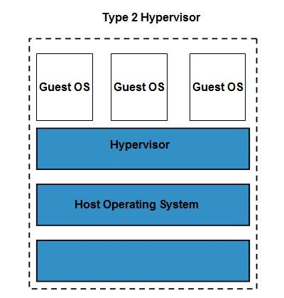

Types of Hardware Virtualization

Here are the three types of hardware virtualization:

* Full Virtualization
* Emulation Virtualization
* Paravirtualization

Full Virtualization

In **full virtualization,** the underlying hardware is completely simulated. Guest software does not require any modification to run.

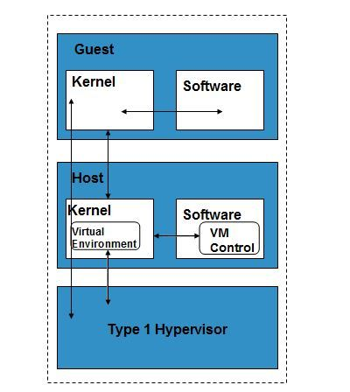

Emulation Virtualization

In **Emulation,** the virtual machine simulates the hardware and hence becomes independent of it. In this, the guest operating system does not require modification.

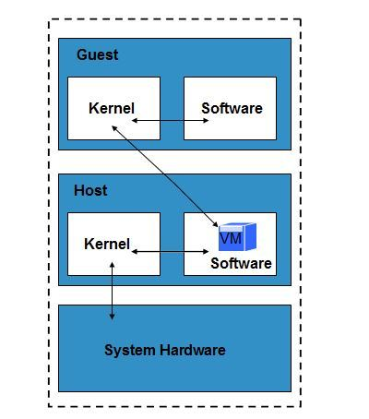

Paravirtualization

In **Paravirtualization,** the hardware is not simulated. The guest software run their own isolated domains.

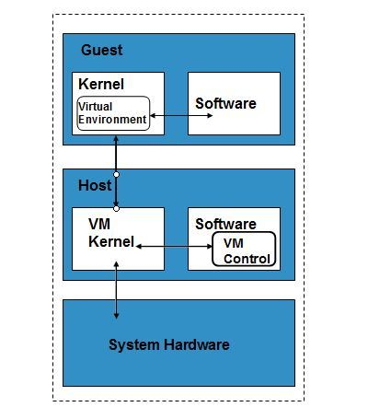

VMware vSphere is highly developed infrastructure that offers a management infrastructure framework for virtualization. It virtualizes the system, storage and networking hardware.

|  |
| --- |
| **What is Virtualization in cloud computing?** |
| Virtualization is the network infrastructural process in which diversified networks will consolidate into single virtual entry. |
| IT resources can be scaled up and down virtually to provision on-demand services without the addition of new physical devices or entities through server virtualization. |
| Virtualization is a process where multiple operating system and applications run on a single computer. |
| Virtualization is a process which Consolidate hardware to get vastly higher productivity from fewer servers. |

|  |
| --- |
| **What are the various types of virtualization in cloud computing?** |
| Hardware virtualization |
| Operating System virtualization |
| Database virtualization |

|  |
| --- |
| **What are the various types of hardware virtualization in cloud computing?** |
| Full virtualization |
| Emulation System virtualization |
| Para virtualization |
|  |

|  |
| --- |
| **What is Operating System virtualization?** |
| Operating system virtualization (OS virtualization) is a server virtualization technology that involves tailoring a standard operating system so that it can run different applications handled by multiple users on a single computer at a time. |